Streaming RTSP Stream.

**CAMERA DIRECT.**

Open VLC and select Network Stream

Insert Stream Key RTSP://<USER>:<PASSWORD>@<IP ADDRESS>/ISAPI/Streaming/Channels/10x

10x = 101 MS / 102 SS

Example user admin pw 12345 ip 192.168.1.1

RTSP://admin:12345@192.168.1.1/ISAPI/Streaming/Channels/102

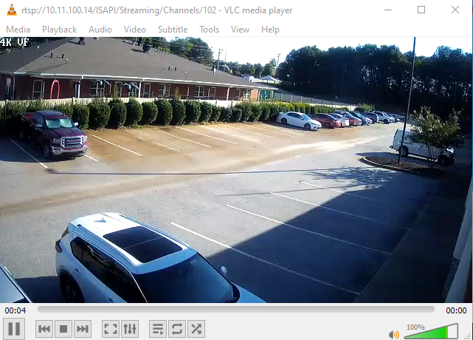

**NVR DIRECT**

rtsp://<username>:<password>@<IP address of device>:<RTSP port>/Streaming/channels/<channel number><stream number>

NOTE: <stream number> represents main stream (01), or the sub stream (02)

Example:

rtsp://admin:12345@173.200.91.70:10554/Streaming/channels/101 – get the main stream of the 1st channel

rtsp:// admin:12345@173.200.91.70:10554/Streaming/channels/102 – get the sub stream of the 1st channel

